Web Application Using Node-Red

Team ID: PNT2022TMID40641

Project Name: IoT Enabled Smart Farming Application Date:15th November 2022

Flow 1

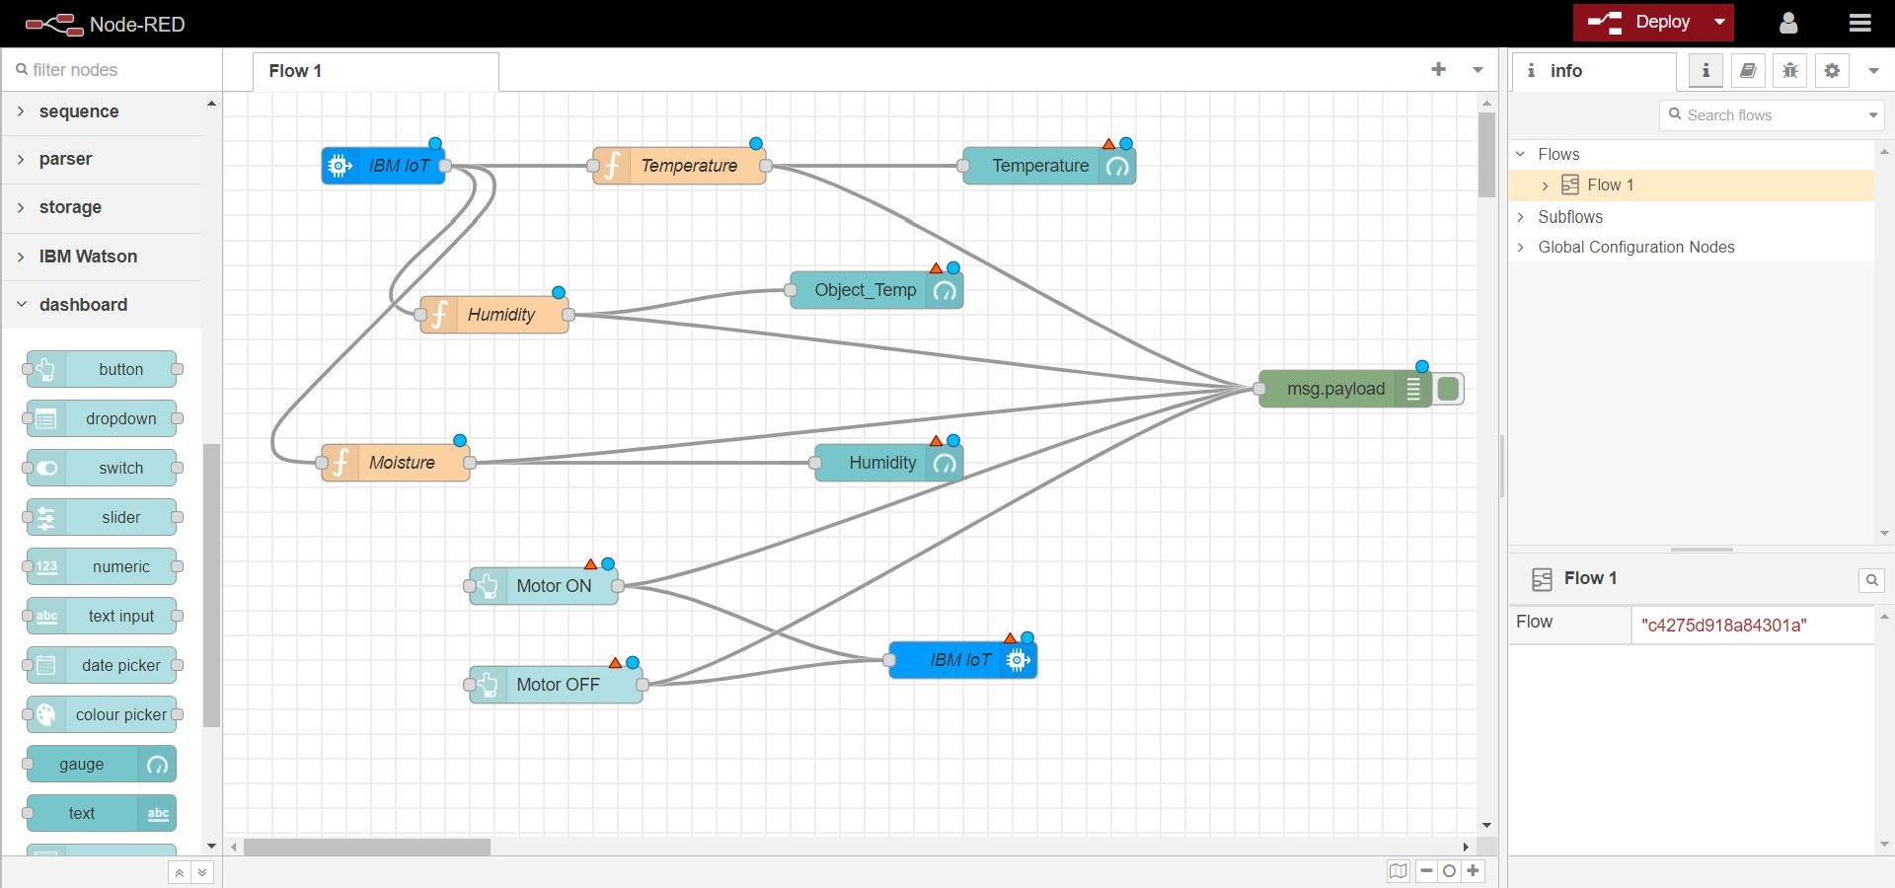

Flow 2:

